**The United Kingdom of Great Britain and Northern Ireland**

**Aims of the Lesson**:  
1. Consolidation of Unit 2 and revision of all materials about the UK.  
2. To check up their knowledge of this theme.  
3. To able to speak about the UK  
4. Develop communicative, reading, creativity skills  
5. Stimulate students interest reading on British history, culture, traditions.  
  
**TIME REQUIRED: 45 minutes.  
MATERIALS REQUIRED:**1. Union Jack and flags of 4 parts of the UK  
2. Colored markers for each student.  
3. Notebook   
4. Resources from Internet about the UK.  
  
**Block of lessons:**L #1 Teacher’s words.  
L #2 Role Play (Students’ Presentations)  
L #3 Warm - up ( Intellectual Game “Jeopardy”)  
L #4 Grammar  
L #5 Warm - up (Listening Comprehension, Writing.....”Filling in the blanks” Song “Yesterday”)  
L #4 Conclusion.  
  
**PROCEDURE:  
1. Greeting**- Good morning dear children, good morning our guests! It’s great to see the guests at our English lesson today. I hope everybody is OK. I am sure that all people like to travel. We learn English language and its very interesting for us to visit the UK. So, I offer you to have an imaginary trip to GB today.  
Today we shall travel to the UK by plane. In order by plane we need a pilot, a stewardess, guides and passengers.  
Let’s start our lesson.  
**2. Introductory Activity:  
Pilot:**Good morning Ladies and Gentlemen! **“British Airways**” are glad to meet you. I’m your pilot, Mr. Alibek and I wish you a pleasant flight.  
**Stewardess:**  
Dear Ladies and Gentlemen! I am your stewardess. My name is Diana Amanzholovna. Welcome to our plane. Our flight lasts 4 hours and we shall land in London at 12 o’clock. The speed of plane is 600 km/hour. The high is 5000 meters. The temperature outside is 12 degrees below zero.  
“British Airway” wish you pleasant flight.

Teacher:  
Now imagine that we are on board plane. We are sitting comfortably in our armchairs and listening some information about GB. Tell me, please. What do people usually do while they are flying by plane?  
Pupils:  
Read books, newspapers, magazines, listen to music, talk, solve crosswords, puzzles, have lunch.  
Teacher:  
Before visiting the UK we have read and we have looked for some interesting information about this country. So, let’s see what we know about this country. Before listening our guides I should notice that you must be attentive. After their presentation we check your knowledge.  
Guide I:  
Hello dear tourists! I am your guide and my name is Erkezhan. I’m glad to welcome you on board our plane. Listen to about the UK.  
The official name of the country is the United Kingdom of Great Britain and Northern Ireland. The UK is situated on the British Isles. The British Isles consists of two large islands, Great Britain and Ireland and a great number of small islands. The area is over 244 000 sq. km. The British Isles are separated from the continent by the English Channel. The western coast of GB is washed by the Atlantic Ocean and the Irish Sea. In the south, it borders on the Irish Republic. The UK consists of 4 countries: England, Scotland, Wales, Northern Ireland. The UK is a parliamentary monarchy state. The head of the country is the Queen Elizabeth II. The flag is called Union Jack because it embodies the emblems of 3 countries.

**The United Kingdom of Great Britain and Northern Ireland**

England Wales Scotland  Northern Ireland

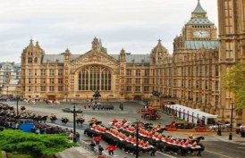 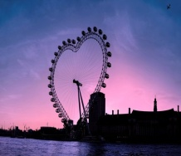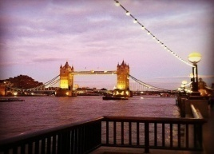 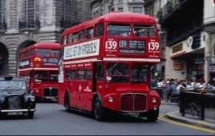

Guide II:  
Hello! I’m your guide, my name is Dana. I want to tell you about England. England is the largest and the richest country of Great Britain. It is situated east of Wales and south of Scotland. The capital is London. There are other large industrial cities, such as Birmingham, Liverpool, Manchester, Oxford, Cambridge. The population is over 50 mln. people. Red rose is the symbol of England. The flag has a red cross on a white background.

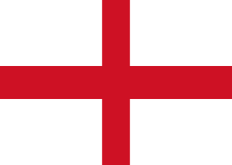 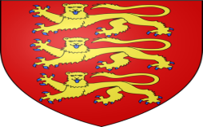 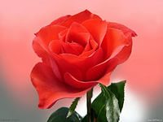

Guide III.  
Good day! My name is Aitgul. I want to tell you about Scotland. Scotland is in the north of GB. The capital of Scotland is Edinburgh, well known for its castle. Glasgow is the industrial capital, the third largest city in GB. Scotland is full of mountains and lakes. The highest mountain is Ben Nevis. Scotland is also the land of myths and mysteries. And of course everyone knows about the Loch Ness Monster. The population is over 5 mln. people. The symbol is the thistle. The Scottish flag is a white cross on a blue background.

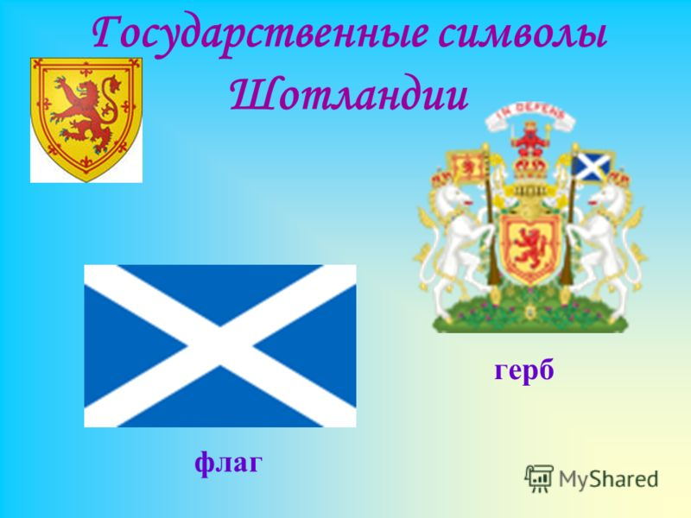

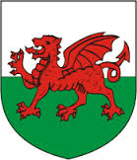

Guide 4:  
Hi! My name is Kanat.. I’m your guide, too. And I want to tell you about Wales. Wales is the country in the west of GB. It’s the country of lakes and mountains. Wales is agricultural and industrial centre. The landscape is very beautiful. Cardiff is the capital of Wales. The population is over 3 mln. people. The flag has the red dragon, The daffodil is the symbol of Wales

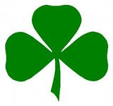 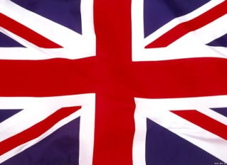

Guide 5:  
You are welcome to our plane! I want to tell you about the Northern Ireland. This country lies on Ireland The capital of the country is Belfast. Belfast is also the most important port and commercial, industrial centre. Northern Ireland has strong cultural tradition: songs, dances, literature and festivals. The symbol is the shamrock.  
  
**3. Practice the concept:**  
Game “Jeopardy”  
**4. Independent Practice:  
Grammar.**Teacher: Thank you. We continue our trip. Now let’s do some grammar practice. Don’t forget that the names of cities towns and countries are used without articles, but the nationality words like the Welsh, the English are used with Definite article “the”. Also we use definite article with the names of oceans, seas, rivers. Don’t forget not to use the article with the language people speak.

And now, we‘ll do a short test. Your task is to fill in the articles where necessary.

1.... British Isles are a group of islands where... UK is situated.  
2.... Thames is the most famous river in... United Kingdom.  
3. Most of the rivers flow into... North Sea.

4. The main nationalities are:... English,... Welsh,... Scottish and... Irish.  
5.... United Kingdom is... parliamentary monarchy.  
6.... Oxford is the home of the oldest university of... England.  
7.... Irish population is devided into two groups:... Protestants and... Catholics.  
8.... Welsh is an ancient... Celtic language.  
9.... Scotland is devided into three natural regions:... Southern Uplands,... Central Lowlands and... Highlands and... islands.  
10. The flag of.... Great Britain is known as.... Union Jack  
**5 Warm - up**.  
Teacher: Do you know one of the well - known british group? … Yes you are quite right. It’s Beatles. Now let’s listen to the song “Yesterday” twice after that you must fill in missing words. You see sheets of papers on your desks. … Let’s check

**6. Conclusion:**A) Giving marks  
B) Home task